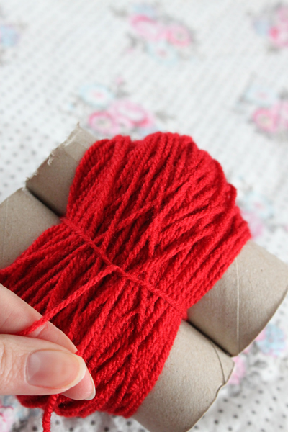
Making a Pompom with Cardboard Tubes

1.You need yarn, a pair of sharp scissors and an empty kitchen roll. Cut the roll into two parts. It works with the toilet rolls too, but household rolls are a little stronger.
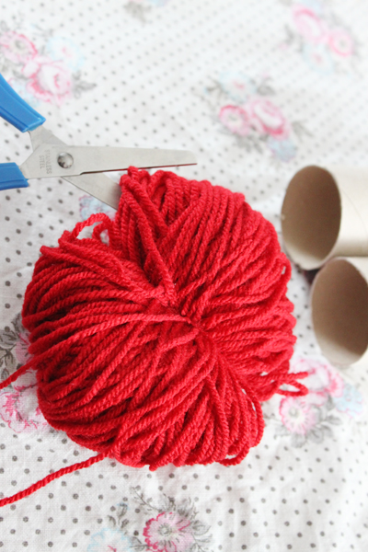
2. Hold the kitchen rolls together and begin to wrap around and around. Repeat. Try to wrap evenly, working back and forwards, working in layers. The amount of yarn determines how thick and full your pompom will be.

3. Once you've wrapped enough, take a 30-40cm piece of cut yarn and slide it between the tubes, then tie a knot around the wrapped yarn as tightly as possible. Slide the yarn off the tubes and check your knot is tight. Tie again if needed.

4. Cut the yarn ends. At this stage it will look very messy and probably not pompom shaped. Hold the long strands that you tied with so you do not accidentally cut them. Using a pair of sharp scissors, trim until you have a round pompom shape.

Use the long threads to tie to your project.

