How to Make Tassels
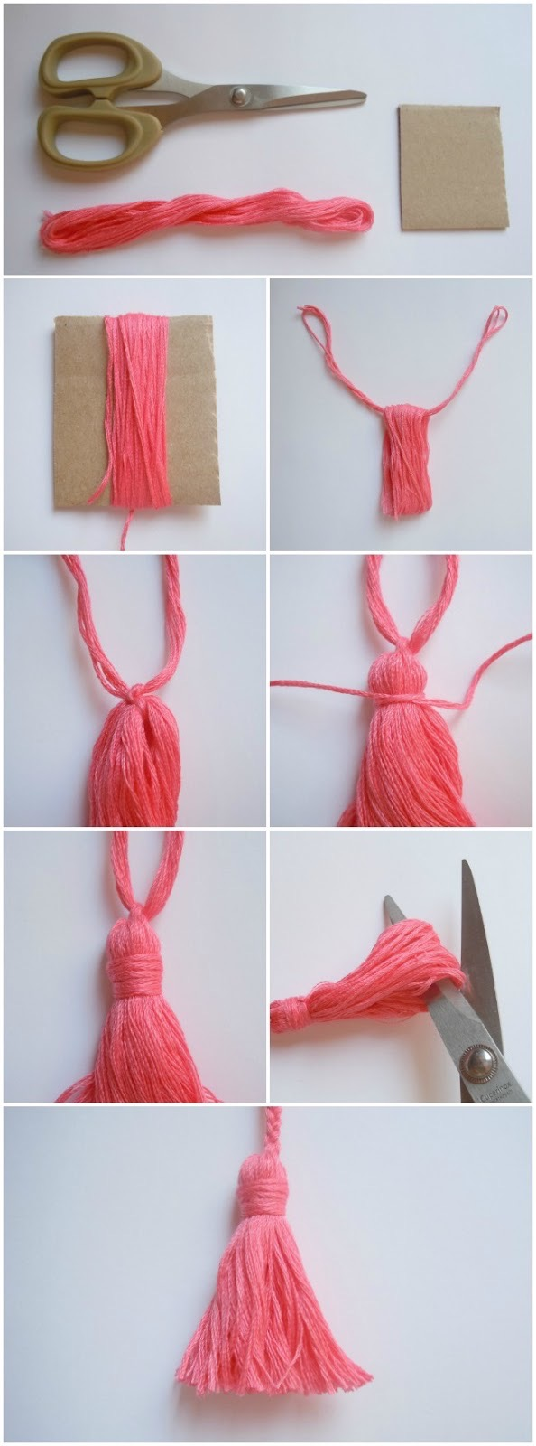

1 .Cut a winding board from heavy card stock, cardboard, or foam board; the board should be slightly longer than the length of the finished tassel (allows you to trim uneven ends).
Wind thread around board in taut, but not too tight, loops until you reach desired fullness.

Wind 20-40 times depending on fullness wanted.

2. Cut a 50-70cm long piece of yarn. Have it nearby. Slide the wound thread off the board, and centre the thread through it as shown in the photos. Tie a knot to keep it stable.

3. Cut a 30cm length of yarn. Tie a knot tightly around the wound yarn, near the top of the tassel as shown in the photo.

Wrap the remaining yarn slowly, working from the top of the neck down, so neck threads lie evenly next to one another. As you wrap, ensure all the threads in the head and skirt are neatly in place. Tie ends again to secure.

4. Trim tassel ends, a few threads at a time. You can trim further to make even them if necessary. Use the tie-off threads on top of the tassel to attach it to your project.

Note:
In a group project or garland, all the tassels should be the same fullness and length.

