Hearts and Flowers Hanging Yarnbombs
by Queen Babs Copyright 2016

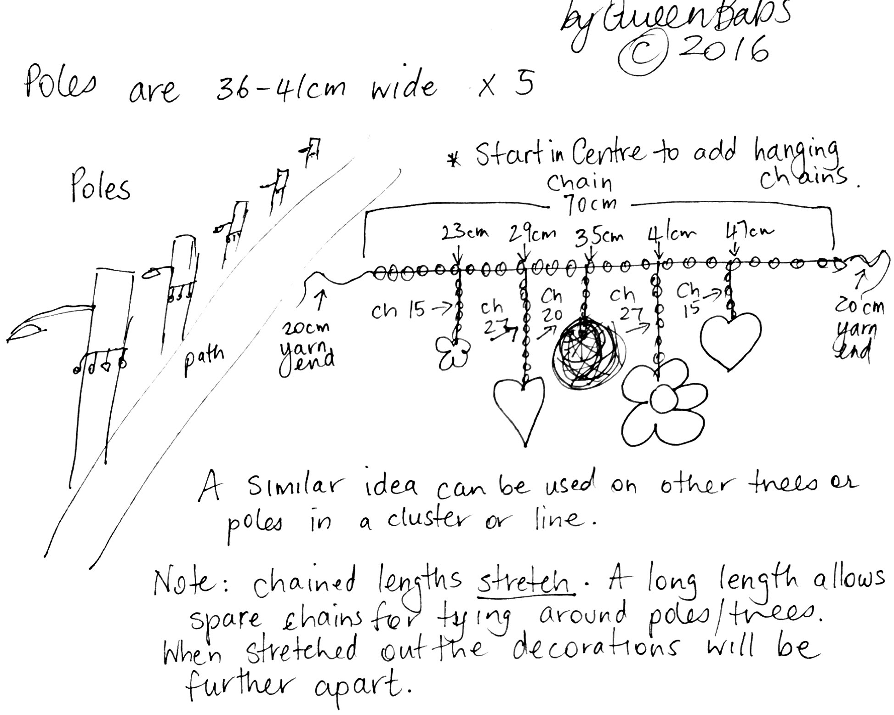

Use green yarn for the crochet chain ties and hanging strips. 5 decorations in assorted colours.

- Leave a 20cm tail and chain a 70cm long length. Finish off and leave a 20cm ending tail. This 70cm chain is the length that will be tied around the pole or tree. The other chained pieces will hang from it with attached pom-poms, hearts and flowers.
- In the centre of the 70cm tie, slip stitch into the centre chain and then chain 20. Finish off and weave in ends.
- Measure 6cm to the left of the centre hanging chains. Slip stitch into that chain and then chain 27. Finish off and weave in ends.
- Now measure a further 6cm to the left of the last hanging chain just completed. Slip stitch into that chain and then chain 15. Finish off and weave in ends
- Measure 6cm to the right of the centre hanging chains. Slip stitch into that chain and then chain 27. Finish off and weave in ends.
- Now measure a further 6cm to the right of the last hanging chain just completed. Slip stitch into that chain and then chain 15. Finish off and weave in ends
- Sew a variety of decorations in your chosen colours to the ends of these hanging chains. Weave in any ends and trim neatly.

Possible decorations: anything small enough to not interfere with the other decorations and not too heavy to pull the hanging down: hearts, flowers and pom-poms.

