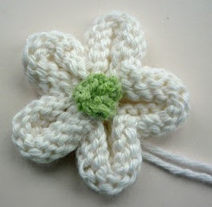
Knitted Flower Tutorial
By: Julie Taylor from Mack and Mabel Knitted Flower Tutorial

Knitting Needle Size: 6 or 4 mm with 8ply Light/DK or 5mm with 10ply worsted

Instructions
Cast on 51sts and starting with a knit row, work 4 rows stocking stitch (stockinette)

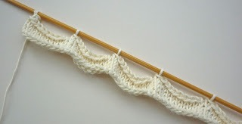
5th Row: Knit 1, [cast off 9sts] five times. You should have 6sts on your needle and your work should look like this.

Leaving a good length, cut the yarn and thread it through the remaining stitches. Pull the yarn tight to draw them together and fasten yarn securely.

Now make the centre of the flower. Using a contrasting yarn, cast on 2 stitches.
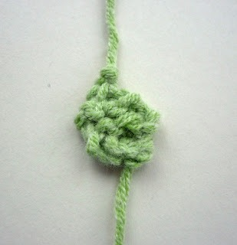
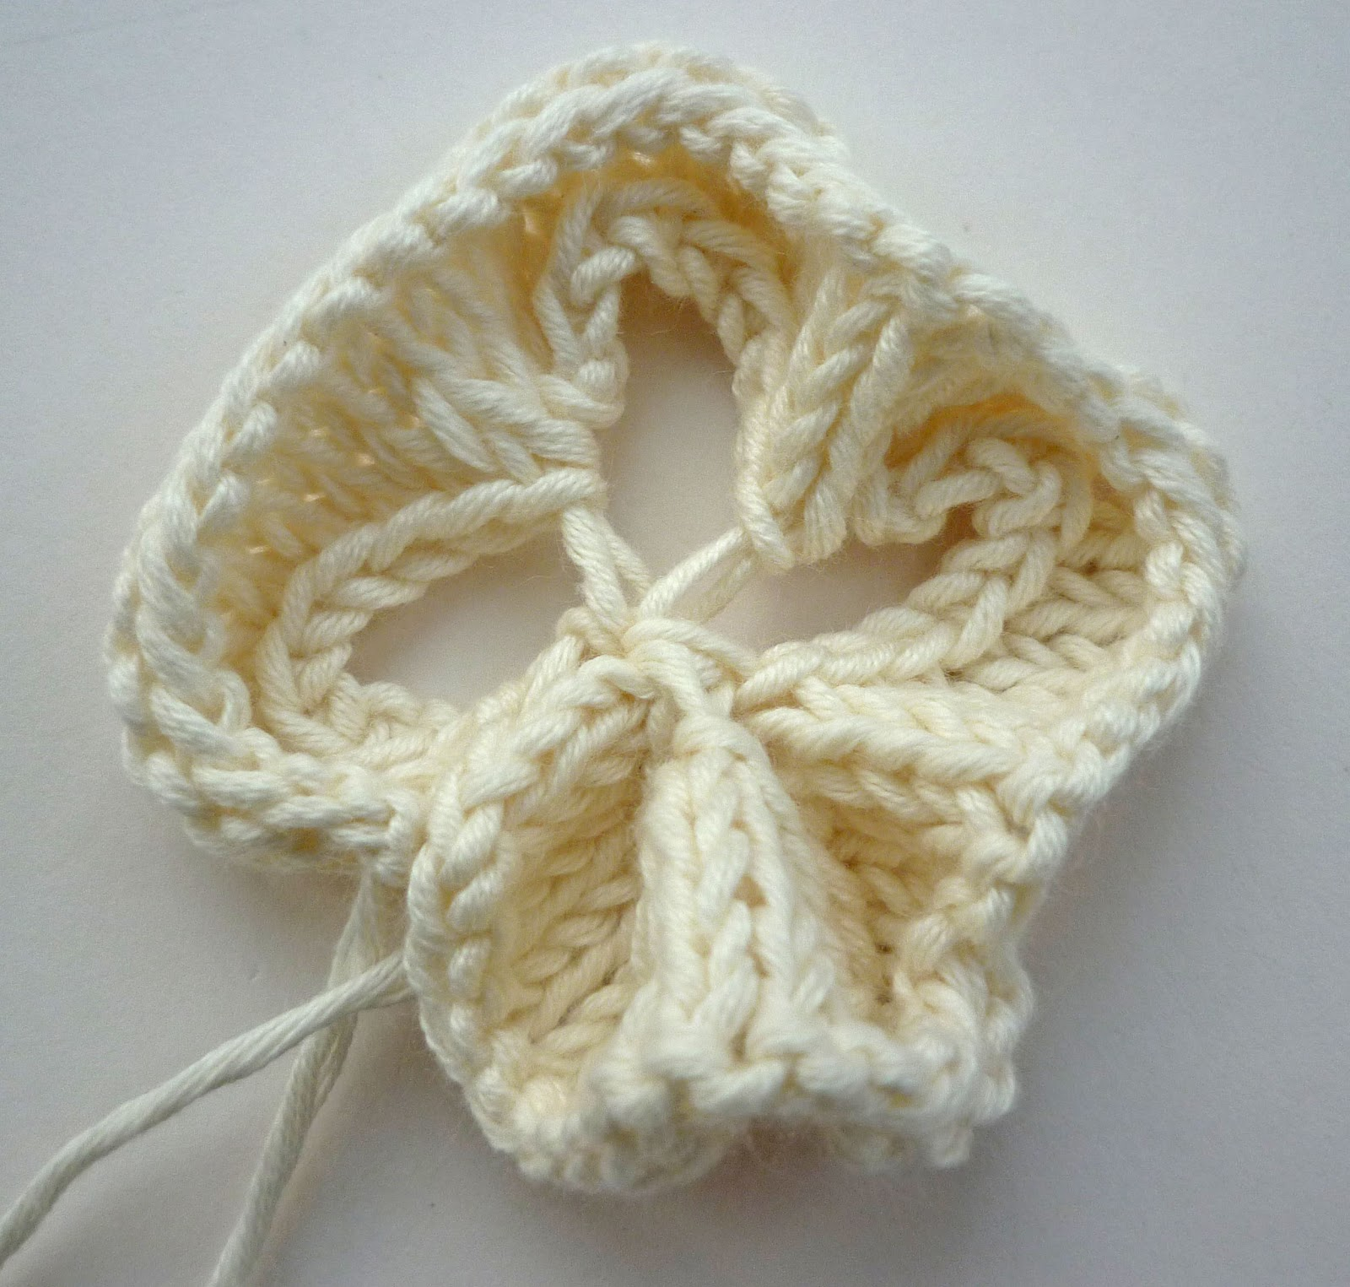
1st Row: Increase in both those stitches to make 4 stitches - this is where you start cursing if you've cast on too tight!
2nd, 3rd and 4th Rows - just plain knit every row.
5th Row: [K2together] twice ....... just 2 stitches left on your needle now, and almost done!
6th Row: K2together and fasten off.

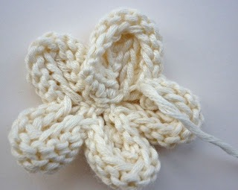
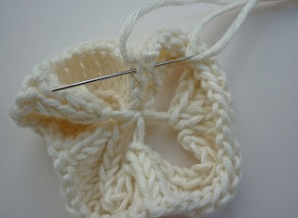
Now we go back to the main bit of the flower and use one of those dangling ends to sew the two little ends so that the flower is circular.

Use that same yarn that's still on your needle and thread it across from one petal to the next, pulling them all in close together - still don't cut that yarn!!!

Turn the flower over and sew on the centre - you can just actually thread those green yarn ends to the back of the flower and tie them in a secure knot.

Use the threads to sew the flower to your hat/blanket/bag/or whatever!

